Ms. Young’s IDEC Portfolio
Fall Semester 2017
(Portfolio Title/Semester)

“Work hard, have fun, no drama!”
(Inspirational Quote)

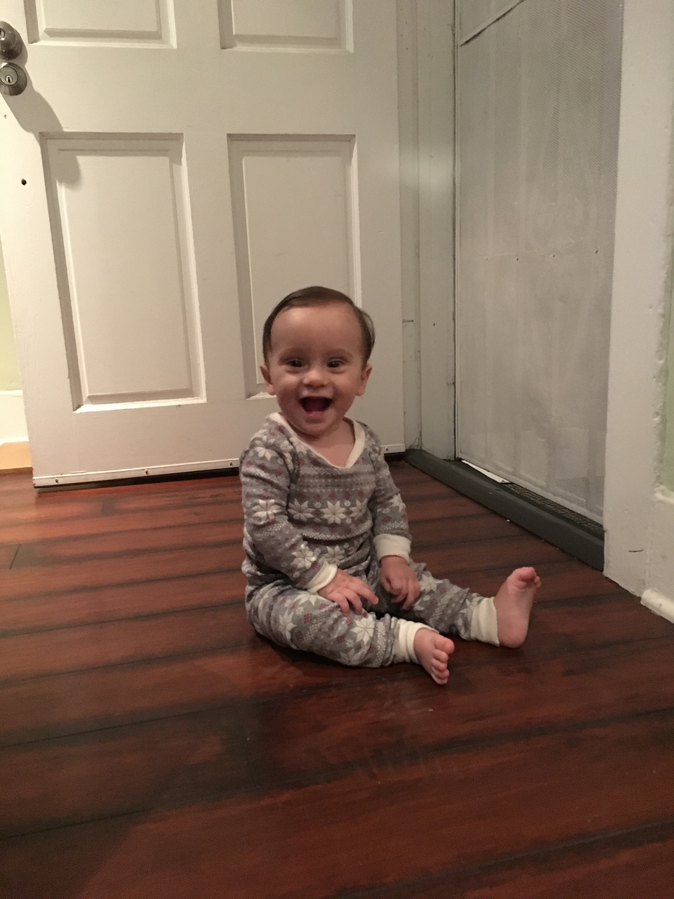

(Insert Image)

