**What’s My Word?**

*Does my word have any prefixes, suffixes, or roots?*

*Prefix_________*

*Suffix_________*

*Root__________*

**Initials: __________**

Outside of this class where are you

most likely to see, hear, use, or find

this word?

________________________________

________________________________

________________________________

Possible answers:

* A television show about _______.
* My mom/dad/brother/friend might say it when he/she is talking about __________.
* A book about ___________.
* In a ____________ store. **Initials: __________**

My word in a sentence:

(leave a blank where the word

should go)

________________________________

________________________________

________________________________

________________________________

________________________________

________________________________.

**Initials: __________**

Here is a word, or phrase that means (choose 1):

* The same _______________
* The opposite

______________

**Initials: __________**

**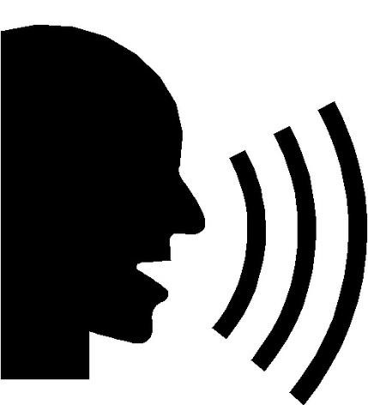*Tell me an example of my word.*** For example, if my word

is “connect” you might say, “An example is what happens

when a power cord is plugged into an outlet.” OR “An example

is when two people like each other right away.” **Initials: __________**

***YOU CAN ONLY ANSWER AFTER ALL OF THE BOXES ARE FILLED OUT!***

*I think my word is __________________________________.*

***Circle one:***

*I was correct* ***OR*** *I was incorrect my word was _________________________.*

A picture of my word:

**Initials: __________**

**Initials: __________**