What’s My Word?
1. Ask a friend about your word.
2. Have the person write their name.
2. Where can I or my word?
Choose only 1:

1. A TV show about _________________________.

2. When ___________________ is talking about ___________________.

3. A book about _________________________________.

4. In a _____________________________store.

Name: __________

3. You can only go to a person once.
4. You must go in order 1-7!
5. Fill out everything before you guess.
1. A picture of my word:
Name: __________

Initials: __________
7. I think my word is __________________________________.

8. √ one: Correct______________ Incorrect_________________

My Name: __________

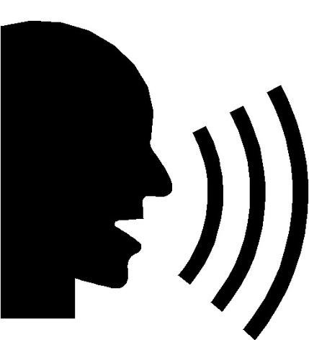
6. Tell me an example of my word.

Name: __________
5. Choose only 1:

a. Prefix_________
b. Suffix_________
c. Root__________

Name: __________
4. My word in a sentence:
(Put a ____________ where the word should go)
________________________________
________________________________
________________________________
________________________________
________________________________
________________________________.
Name: __________

3. This means the same thing as my word: ____________________
____________________
____________________

Name: __________

